**Experimental and numerical investigations of … “Arial, 12points, bold”**

1*Name Surname, 2Name Surname, 3Name Surname, “Arial, 9points”

1 Affiliation University, Faculty, Department, InstituteAddress, City, Postal Code, Country“Arial, 9points”

2 Affiliation University, Faculty, Department, InstituteAddress, City, Postal Code, Country

3 Affiliation University, Faculty, Department, InstituteAddress, City, Postal Code, Country

* E-mail:xxx@yyy.com“Arial, 9 points”

**Abstract**

“Arial, 10 points” Example of text text text text text text text text text text text text text text text text text text text text text text text text text text text text text text text text text text text text text text text text text text text text text text text text text text text text text text text text text text text text text text text text text text text.Text text text text text text text text text text text text text text text text text text text text text text text text text text text text text text text text text text text text text text text text text text text text text text text text text text text text text text text text text text text text text text text text text text text text text text text text text text text text text text text text text text text text text text text text text text (Williamson,1989). Text text text text tetext text text text text text text text text text text text text text text text text text text text text text text text text text text text text text text text text text text text text text text text text text text text text text text text text text text text text text text text text text text text xttext text texttext text texttext text text.

**Keywords:“Arial, 10 points, bold”** Keyword, keyword, keyword, “Arial, 10 points”

**I. Introduction“Arial, 10 points, bold”**

“Arial, 10 points”Exampleof texttext texttext texttexttexttexttexttexttext text text text text text text text text text text text text text text text text text text text text text text text text text text text text text text text text text text text text text (Escriva,1999). text text text text text text text texttext text text text text text text.

Text text text text text text text text text text text text text text text texttext text text text text text text text by Zovatto and Pedrizzetti (2001).Text text text text text text text text text text text text text text text text text text text text text text text text text text text text text text text text text text text texttext text text text text text text text text text text text text text text text text text text text text text text textText text text text text text text text text text text text text text text text text text text text text text text text by Escriva (1999). Text text text text text text text text text text text text text text text text text text text text text text text text text text text text text text text text text text text text text text text text text text text text text text text text text text text text text text text text text text text textText text text text text text text text text text text text text text text text text text text text text text text text by Graftieauxetal. (2001). Text text text text text text text text text text text text text text text text text text text text text text text text text text text text text text text text text text text text text text text text text text text text text text text text text text text text text text text text text text text textText text text text text text text text text text text text text text text text text text text text text text text text. Text text text text text text text text text text text text text text text text text text text text text text text text text text text text text text text text text text text text text text text text text text text text text text text text text text text text text text text text text text text textText text text text text text text text text text text text text text text text text text text text text text text text. Text text text text text text text text text text text text text text text text text text text text text text text text text text text text text text text text text text text text text text text text text text text text text text text text text text text text text text text text text text text textText text text text text text text text text text text text text text text text text text text text text text text text. Text text text text text text text text text text text text text text text text text text text text text text text text text text text text text text text text text text text text text text text text text text text text text text text text text text text text text text text text text text text textText text text text text text text text text text text text text text text text text text text text text text text text by. Text text text text text text text text text text text text text text text text text text text text text text text text text text text text text text text text text text text text text text text text text text text text text text text text text text text text text text text text text text text textText text text text text text text text text text text text text text text text text text text text text text text text. Text text text text text text text text text text text text text text text text text text text text text text text text text text text text text text text text text text text text text text text text text text text text text text text text text text text text text text text text text text text textText text text text text text text text text text text text text text text text text text text text text text text text by Escriva (1999).Text text text text text text text text text text text text text text text text text text text text text text text text text text text text text text text text.

Text text text text text text text text text text text text text text text text text text text text text text text text text text text text text text text text text text text text text text text text text text text text text text text text text text text text text text text text text text text text text text text text text text text text text text text text text text text text text text text text text text text text text text text texttext text text text text text text text text text text text text text text text text text text text text textext text text text text text text text texttext text text text text text text text text text textby Zovatto and Pedrizzetti (2001).

**II. Experimental Facility“Arial, 10 points, bold”**

***II.1. Setup*“*Arial, 10 points, Italic, bold*”**

“Arial, 10 points” Text text text text text text text text text text text text text text text text text text text text text text text text text text text text text text text texttext text text text text text text text text text text text text text text text text text text text text text text text text text text text text. Text text text text text text text text text text text text text text text text text texttext text texttext text text text text text text text text text text text.

**P**

**F1**

Electromagnetic flowmeters

Test section

Heatexchanger

Tank

Pump

Conical diffuser

Elbows

By-pass

Valve

Pressurization

system

**F2**

Fig. 1:“Arial, 9 points, Centered, and graph aligned on the text”Experimental installation

Text text text text text text text text text text text text text text text.Text text text text text text text text text text text text text text text text text text text text text text text text. Text text text text text text text text text text text text text text text text text text text text text text text text text text text text text text text text text text text text text text text text text text text text text text text text text text text text text text text text text text text text.

Text text text text text text text text text text text text text text text text text text text text text text text text. Text text text text text text text text text text text text text text text text text text text text text text text text text text text text text text text text text text text text text text text text text text text text text text text text text text text text text text text text text text text textText text text text text text text text text text text text text text text text text text text text text text text text. Text text text text text text text text text text text text text text text text text text text text text text text text text text text text text text text text text text text text text text text text text text text text text text.

**A**

**B**

**C**

**D**

75

φ41

φ62.7

Diffuser

16°

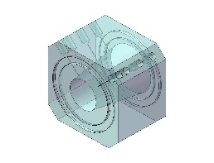

Diffuser

**A**

**B**

**C**

**D**

Fig. 2:“Arial, 9 points, Centered, and graph aligned on the text” Sketch of text text text text.

Text text text text text text text text text text text text text textText text text text text text text text text text text text text text text text text text text text text text text text. Text text text text text text text text text text text text text text text text text text text text text text text text text text text text text text text text text text text text text text text text text text text text text text text text text text text text text text text text text text text textText text text text text text text text text text text text text text text text text text text text text text text text. Text text text text text text text text text text text text text text text text text text text text text text text text text text text text text text text text text text text text text text text text text text text text text text text text text text text text text text text text text text text textText text text text text text text text text text text text text text text text text text text text text text text text.

***II.2. Measurements* “*Arial, 10 points, Italic, bold*”**

Text text text text text text text text text text text text text text text text text text text text text text text text by Zovatto and Pedrizzetti (2001). Text text text text text text text text text text text text text text text text text text text text text text text text text text text text text text text text text text text text text text text text text text text text text text text text text text text text text text text text text text text textText text text text text text text text text text text text text text text text text text text text text text text text by Escriva (1999). Text text text text text text text text text text text text text text text text text text text text text text text text text text text text text text text text text text text text text text text text text text text text text text text text text text text text text text text text text text text textText text text text text text text text text text text text text text text text text text text text text text text text by Graftieaux etal. (2001). Text text text text text text text text text text text text text text text text text text text text text text text text text text text text text text text text text text text text text text text text text text text text text text text text text text text text text text text text text text text textText text text text text text text text text text text text text text text text text text text text text.

Text text text text text text text text text text text text text text text text text text text text text text text text text text text text text text text text text text text text text text text text text text text text text text text text text text text text text text text text text text text textText text text text text text text text text text text text text text text text text text text text text text text text. Text text text text text text text text text text text text text text text text text text text text text text text text text text text text text text text text text text text text text text text text text text text text text text text text text text text text text text text text text text text textText text text text text text text text text text text text text text text text text text text text text text text text. Text text text text text text text text text text text text text text text text text text text text text text text text text text text text text text text text text text text text text text text text text text text text text text text text text text text text text text text text text text text textText text text text text text text text text text text text text text text text text text text text text text text text by. Text text text text text text text text text text text text text text text text text text text text text text text text text text text text text text text text text text text text text text text text text text text text text text text text text text text text text text text text text text text textText text text text text text text text text text text text text text text text text text text text text text text text. Text text text text text text text text text text text text text text text text text text text text text text text text text text text text text text text text text text text text text text text text text text text text text text text text text text text text text text text text text text text textText text text text text text text text text text text text text text text text text text text text text text text text by Escriva (1999).Text text text text text text text text text text text text text text text text text text text text text text text text text text text text text text text text text text text text text text text text text text text text text text text text text text text text text.

**III. Numerical scheme“Arial, 10 points, bold”**

“Arial, 10 points” Text text text text text text text text text text text text text text text text text text text text text text text text text text text text text text text text text text text text text text text text text text text text text text text text text text text text. Text text text text text text text text text text text text text text text text text text text text text text text text text text text text text text text text text text text text text text text text. Text text text:

$\frac{dg}{dt}=\frac{∂g}{∂t}+grad\left(g\right).\overset{⃑}{V}$ (1)

and

$\frac{d\overset{̿}{T}}{dt}=\frac{d\overset{̿}{T}}{dt}+\left(\overset{⃑}{V}.\overset{⃑}{n}\right).\overset{̿}{grad}\left(\overset{̿}{T}\right)$ (2)

Text text text text text text text text text text text text text text text text text text text text text text text text by Zovatto and Pedrizzetti (2001). Text text text text text text text text text text text text text text text text text text text text text text text text text text text text text text text text text text text text text text text text text text text text text text text text text text text text text text text text text text text textText text text text text text text text text text text text text text text text text text text text text text text text by Escriva (1999). Text text text text text text text text text text text text text text text text text text text text text text text text text text text text text text text text text text text text text text text text text text text text text text text text text text text text text text text text text text text textText text text text text text text text text text text text text text text text text text text text text text text text by Graftieaux etal. (2001). Text text text text text text text text text text text text text text text text text text text text text text text text text text text text text text text text text text text text text text text text text text text text text text text text text text text text text text text text text text text textText text text text text text text text text text text text text text text text text text text text text text text text.

Text text text text text text text text text text text text text text text text text text text text text text text text text text text text text text text text text text text text text text text text text text text text text text text text text text text text text text text text text text text textText text text text text text text text text text text text text text text text text text text text text text text text. Text text text text text text text text text text text text text text text text text text text text text text text text text text text text text text text text text text text text text text text text text text text text text text text text text text text text text text text text text text text textText text text text text text text text text text text text text text text text text text text text text text text text. Text text text text text text text text text text text text text text text text text text text text text text text text text text text text text text text text text text text text text text text text text text text text text text text text text text text text text text text text text text text textText text text text text text text text text text text text text text text text text text text text text text text text by Escriva (1999).Text text text text text text text text text text text text text text text text text text text text text text text text text text text text text text text text text text text text text text text text text text text text text text text text text text text text text text text text text text text text.

**IV. Results and discussions“Arial, 10 points, bold”**

“Arial, 10 points” Text text text text text text text text text text text text text text text text text text text text text text text text by Zovatto and Pedrizzetti (2001). Text text text text text text text text text text text text text text text text text text text text text text text text text text text text text text text text text text text text text text text text text text text text text text text text text text text text text text text text text text text textText text text text text text text text text text text text text text text text text text text text text text text text by Escriva (1999). Text text text text text text text text text text text text text text text text text text text text text text text text text text text text text text text text text text text text text text text text text text text text text text text text text text text text text text text text text text text textText text text text text text text text text text text text text text text text text text text text text text text text by Graftieaux etal. (2001).

Text text text text text text text text text text text text text text text text text text text text text text text text text text text text text text text text text text text text text text text text text text text text text text text text text text text text text text text text text text text textText text text text text text text text text text text text text text text text text text text text text text text text. Text text text text text text text text text text text text text text text text text text text text text text text text text text text text text text text text text text text text text text text text text text text text text text text text text text text text text text text text text text text textText text text text text text text text text text text text text text text text text text text text text text text text. Text text text text text text text text text text text text text text text text text text text text text text text text text text text text text text text text text text text text text text text text text text text text text text text text text text text text text text text text text text text textText text text text text text text text text text text text text text text text text text text text text text text text.

Text text text text text text text text text text text text text text text text text text text text text text text text text text text text text text text text text text text text text text text text text text text text text text text text text text text text text text text text text text text textText text text text text text text text text text text text text text text text text text text text text text text text by. Text text text text text text text text text text text text text text text text text text text text text text text text text text text text text text text text text text text text text text text text text text text text text text text text text text text text text text text text text text text textText text text text text text text text text text text text text text text text text text text text text text text text. Text text text text text text text text text text text text text text text text text text text text text text text text text text text text text text text text text text text text text text text text text text text text text text text text text text text text text text text text text text text textText text text text text text text text text text text text text text text text text text text text text text text text by Escriva (1999).Text text text text text text text text text text text text text text text text text text text text text text text text text text text text text text text text text text text text text text text text text text text text text text text text text text text text text text text text text text text text.

Text text text text text text text text text text text text text text text text text text text text text text text text by Zovatto and Pedrizzetti (2001). Text text text text text text text text text text text text text text text text text text text text text text text text text text text text text text text text text text text text text text text text text text text text text text text text text text text text text text text text text text text textText text text text text text text text text text text text text text text text text text text text text text text text by Escriva (1999). Text text text text text text text text text text text text text text text text text text text text text text text text text text text text text text text text text text text text text text text text text text text text text text text text text text text text text text text text text text text textText text text text text text text text text text text text text text text text text text text text text text text text by Graftieaux etal. (2001). Text text text text text text text text text text text text text text text text text text text text text text text text text text text text text text text text text text text text text text text text text text text text text text text text text text text text text text text text text text text textText text text text text text text text text text text text text text text text text text text text text text text text.

Text text text text text text text text text text text text text text text text text text text text text text text text text text text text text text text text text text text text text text text text text text text text text text text text text text text text text text text text text text text textText text text text text text text text text text text text text text text text text text text text text text text text. Text text text text text text text text text text text text text text text text text text text text text text text text text text text text text text text text text text text text text text text text text text text text text text text text text text text text text text text text text text text textText text text text text text text text text text text text text text text text text text text text text text text textEscriva (1999).Text text text text text text text text text text text text text text text text text text text text text text text text text text text text text text text text text text text text text text text text text text text text text text text text text text text text text text text text text text text text.

Text text text text text text text text text text text text text text text text text text text text text text text text by Zovatto and Pedrizzetti (2001). Text text text text text text text text text text text text text text text text text text text text text text text text text text text text text text text text text text text text text text text text text text text text text text text text text text text text text text text text text text text textText text text text text text text text text text text text text text text text text text text text text text text text by Escriva (1999). Text text text text text text text text text text text text text text text text text text text text text text text text text text text text text text text text text text text text text text text text text text text text text text text text text text text text text text text text text text text textText text text text text text text text texttext text text text text text text text text text text text text text text text text text text text text text text text text text text text text textText text text text text text text text text text text text text text text text text text text text text text text text by Graftieaux etal. (2001). Text text text text.



(in cm of water)

Line A

Line B

Line C

Line D

**A**

**B**

**C**

**D**

Fig. 3:“Arial, 9 points, centered, and graph aligned on the text”Example text text text text text text text text text text

Text text text text text text text text text text text text text text text text text text text text text text text text by Zovatto and Pedrizzetti (2001). Text text text text text text text text text text text text text text text text text text text text text text text text text text text text text text text text text text text text text text text text text text text text text text text text text text text text text text text text text text text textText text text text text text text text text text text text text text text text text text text text text text text text by Escriva (1999). Text text text text text text text text text text text text text text text text text text text text text text text text text text text text text text text text text text text text text text text text text text text text text text text text text text text text text text text text text text text textText text text text text text text text text text text text text text text text text text text text text text text text by Graftieaux etal. (2001). Text text text text text text text text text text text text text text text text text text text text text text text text text text text text text text text text text text text text text text text text text text text text text text text text text text text text text text text text text text text textText text text text text text text text text text text text text text text text text text text text text text text text.

Text text text text text text text text text text text text text text text text text text text text text text text text text text text text text text text text text text text text text text text text text text text text text text text text text text text text text textText text text text text text text text text text text text text text text text text text text text text text text text. Escriva (1999).Text text text text text text text text text text text text text text text text text text text text text text text text text text text text text text text text text text text text text text text text text text text text text text text.

Tab. 1:“Arial, 9 points, centered, and table aligned on the text”Example text text text text text text text text text

|  |  |  |  |  |
| --- | --- | --- | --- | --- |
| **Text** | **Text** | **Text** | **Text** | **Text** |
| **Text** | *1* | *2* | *3* | *4* |
| **Text** | *1* | *2* | *3* | *4* |
| **Text** | *1* | *2* | *3* | *4* |
| **Text** | *1* | *2* | *3* | *4* |
| **Text** | *1* | *2* | *3* | *4* |
| **Text** | *1* | *2* | *3* | *4* |

Text text text text text text text text text text text text text text text text text text text text text text text text text text text text text text text text text text text text text text text text text text text text text text text text text text text text text text text text text text text textText text text text text text text text text text text text text text text text text text text text text text text text. Text text text text text text

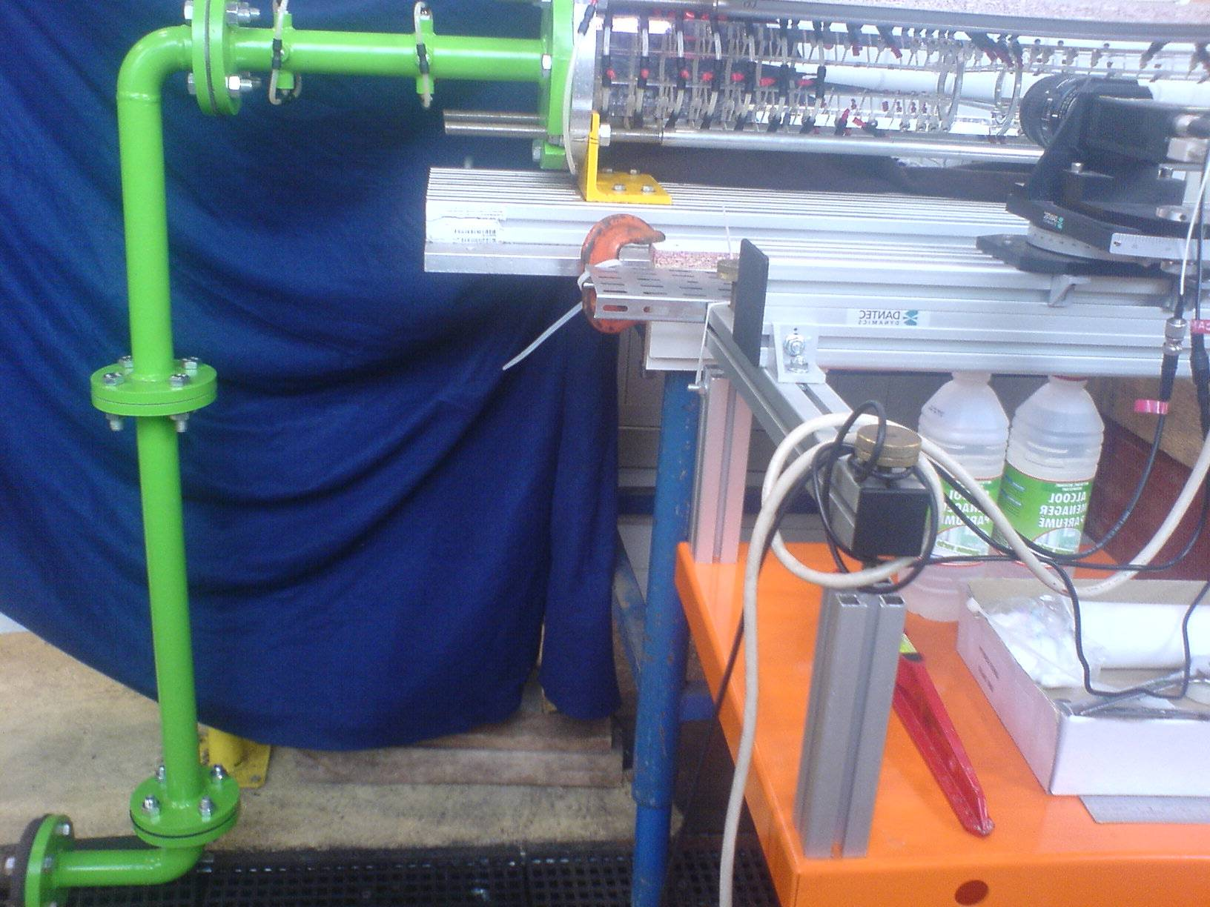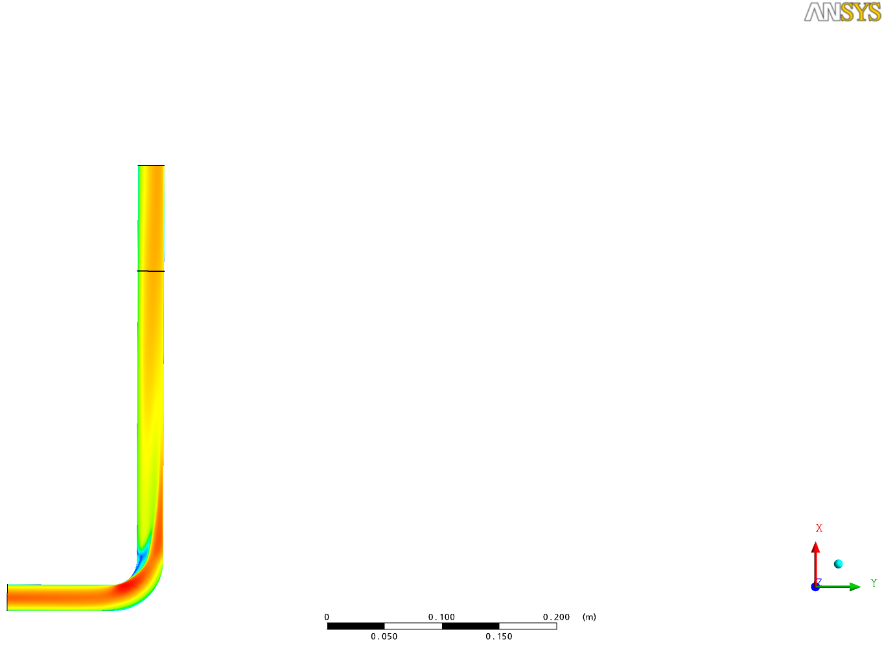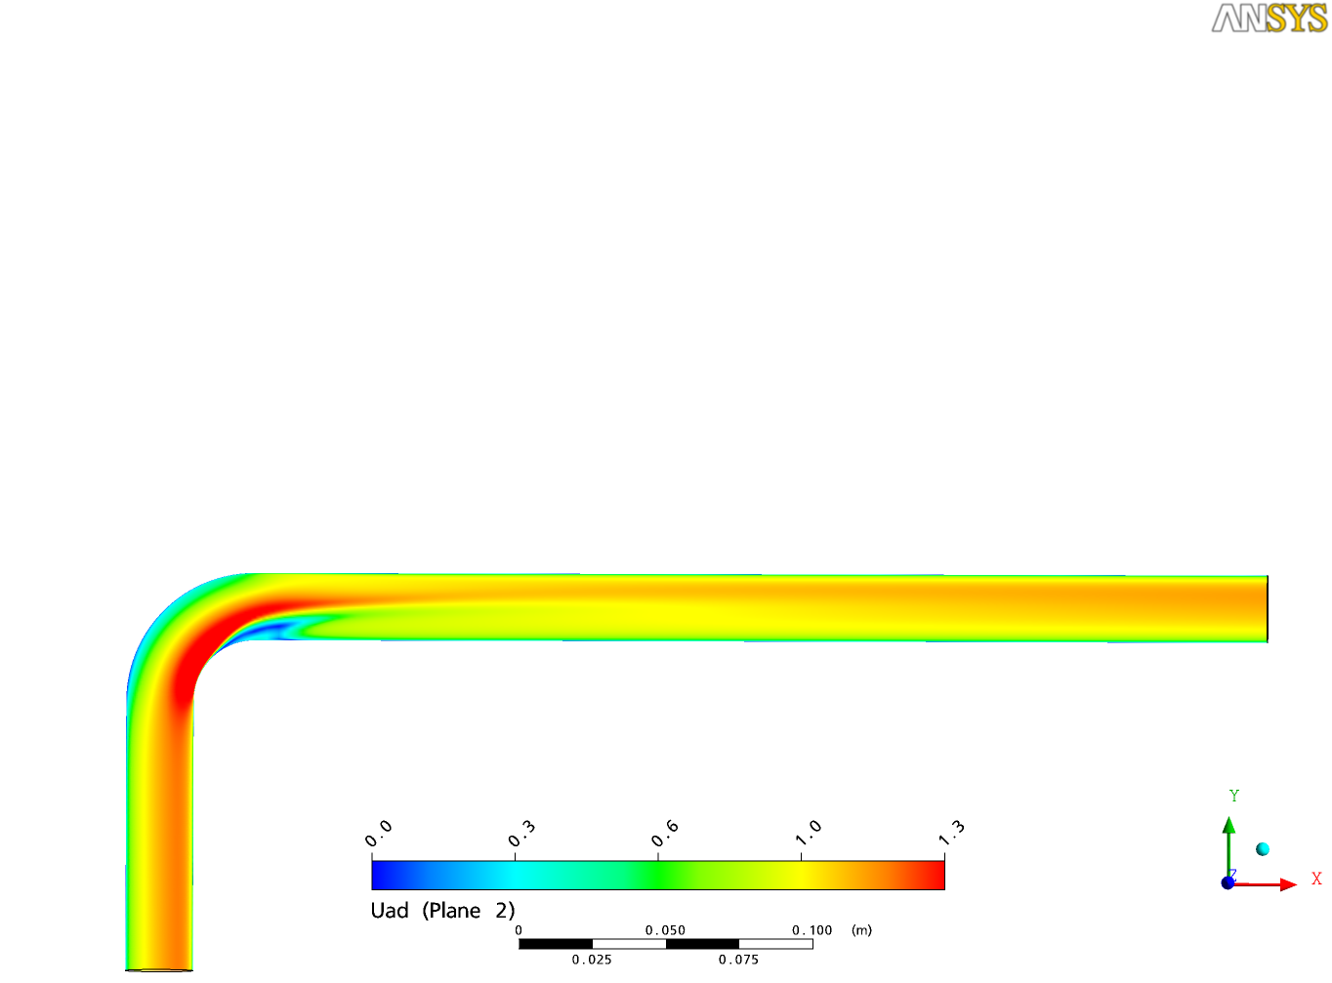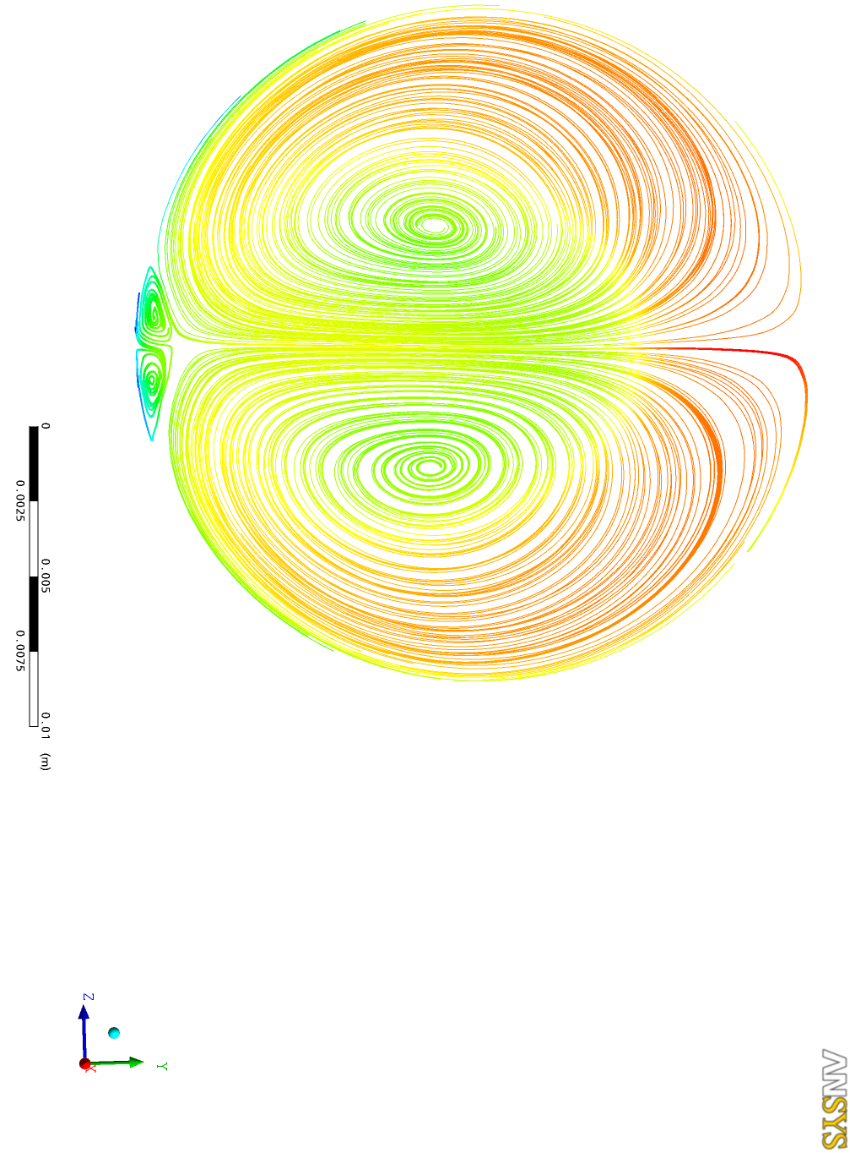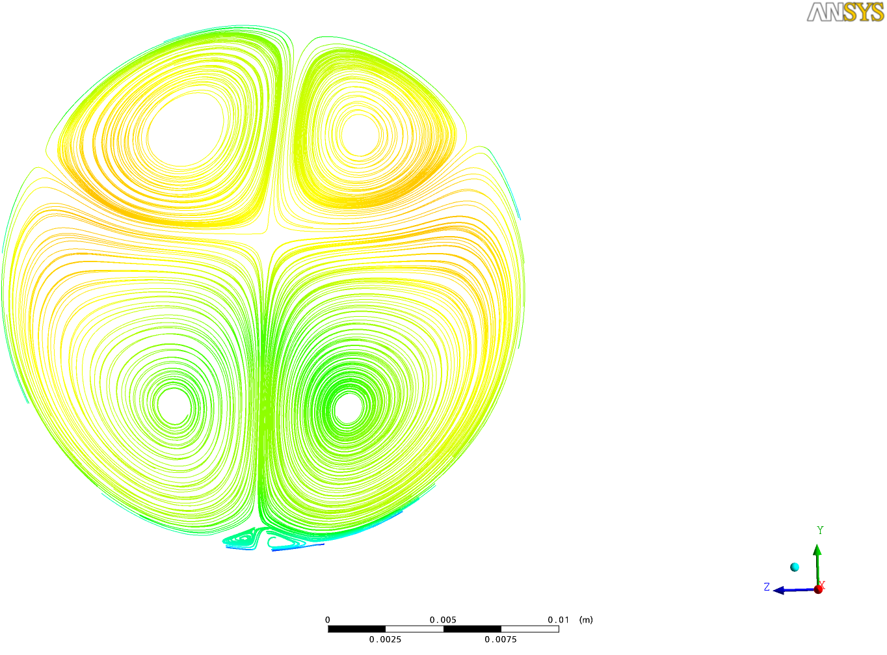

Fig. 4:“Arial, 9 points, centered, and graph aligned on the text”Numerical simulation of text text text text text text text

Text text text text text text text text text text text text text text text text text text text text text text text text by Zovatto and Pedrizzetti (2001). Text text text text text text text text text text text text text text text text text text text text text text text text text text text text text text text text text textText text text text text text text text text text text text text text text text text text text text text text text text by Escriva (1999). Text text text text text text text text text text text text text text text text text text text text text text text text text text text text text text text text text text text text text text text text text text text text text text text text text text text text text text text text text text by Graftieaux etal. (2001).

Tab. 2:“Arial, 9 points, centered, and table aligned on the text”Example text text text text text text text text text

|  |  |  |  |  |
| --- | --- | --- | --- | --- |
| **Text** | **Text** | **Text** | **Text** | **Text** |
| **Text** | *1* | *2* | *3* | *4* |
| **Text** | *1* | *2* | *3* | *4* |
| **Text** | *1* | *2* | *3* | *4* |

Text text text text text text text text text text text text text text text text text text text text text text text text text text text text text text text text text text text text text text textext text text text text text text text text text text text text text text text text text text text text text text text text text.

0

0.25

0.5

0.75

1

1.25

1.5

1.75

X/Dh

0.75

0.50

0.25

0

-0.50

-0.25

-0.75

Y/Dh

Fig. 5:“Arial, 9 points, centered, and graph aligned on the text”Experimental evolution of text text text text text text

Text text text text text text text text text text text text text text text text text text text text text text text text text text text text text text text text text textText text text text text text text text text text text text text text text text text text text text text text text text.

**V. Conclusions“Arial, 10 points, bold”**

“Arial, 10 points” Text text text text text text text text text text text text text text text text text text text text. Text text text text text text text text text text text text text text text text text text text text text text text text text text text text text text text text text text text text text text text text text text text text text text text text text text text text text text text text text text text text text text text text text text text text text text text text text text text text text text.

Text text text text text text text text text text text text text text text text text text text text text text text text text text text text text text text text text text text text text text text text text text text text text text text text text text text text. Text text text text text text text text text text text text text text text text text text text text text text text text text text text text text text text text text text text text text text text text text text text text text text text text text text text text text text text text text text text text text text text text text text text text text text text text text text text text text text.

Text text text text text text text text text text text text text text text text text text text text text text text text text text. Text text text text text text text text text text text text text text text text text text text text text text text text text text text text text text text text text text text text text text text text text text text text text text text text text text text text text text text text text text text text text text text text text text text text text text text text text text text text text text text text text text text text text text text text text text text text text text text text.

Text text text text text text text text text text text text text text text text text text text text text text text text text text. Text text text text text text text text text text text text text text text text text text text text text text text text text text text text text text text text text text text text text text text text text text text text text text text text text text text text text text. Text text text text text text text text text text text text text text text text text text text text text text text text text text.

**Acknowledgements“Arial, 10 points, bold”**

“Arial, 10 points” This research was supported by the text text, the Laboratory text text of the University of text, and the text text. These supports are gratefully acknowledgedtext text text.

**Nomenclature“Arial, 10 points, bold”**

g : Gravitational constant (m.s-1)

p : Pressure (N.m-2)

Greek letters

Φ : Heat transfer coefficient (W.m-2)

μ : Viscosity (Pa.s)

Superscripts

* : Dimensionless

--- : Temporal average

Subscripts

max : Maximum

turb : Turbulent

enr : Energy

**References“Arial, 10 points, bold”**

“Arial, 9 points, alphabetic order of names (fist author)”

Carte G., Dusek J., Fraunié P., A spectral time discretization for flows with dominant periodicity, Journal of Computational Physiscs, 120, 171-183, (1995).

Coutanceau M., Bouard R., Experimental determination of the main features of the viscous flow in the wake of a cylinder in uniform translation, Part 1: Steady flow, Journal of Fluid Mechanics, 79, 231-256 (1977).

Escriva X., Étude dynamique et thermique des transferts pariétaux instationnaires : Application à l’interaction tourbillon couche limite, PhD. Thesis, Université Paul Sabatier, France (1999).

GraftieauxL., Michard M., Grosjean N., Combining PIV, POD and vortex identification algorithms for the study of unsteady turbulentswirling flows, Measurements and Science Technology, 1422-1429 (2001).

Guerrouache M.S., Étude numérique de l’instabilité de Bénard-Kármán derrière un cylindre fixe ou en mouvement périodique, Dynamique de l’écoulement et advection chaotique, Ph.D. Thesis, Université de Nantes (2000).

Natarajan N.M., Lakshmanan S.M., Laminar flow in rectangular ducts: prediction of velocity profiles and friction factor, Indian Journal of Technology, 435-438 (1972).

Sahin M., Owens R.G., A numerical investigation of wall effects up to high blockage ratios on two-dimensional flow past a confined circular cylinder. Physics of Fluids 16, 1305-1320 (2004).

Williamson C.H.K., Defining a universal and continuous Strouhal-Reynolds number relationship for the laminar vortex shedding of a circular cylinder at low Reynolds number, Phys. Fluids, 31, 2742-2752 (1989).

Yang Y., Shehata A., Modi V. , West A. C., Mass transfer to a channel wall downstream of a cylinder, Int. J. Heat Mass Trans., 40, 4263-4271 (1997).